Lab sheet 6

IT24103083- Jayasundara H.J.M.N.D

1. Part 1

Part 2

1. Part 1

Part 2

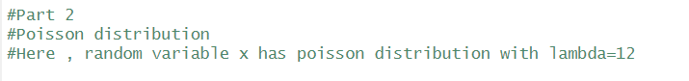



Part 3

